Please take the following steps to Subscribe to the website Forums. Subscribe to those that interest you, but don’t forget to subscribe to the “President’s Corner”.

Step 1.
Go to sunlakescameraclub.com

Step 2.
Select the Login Button.
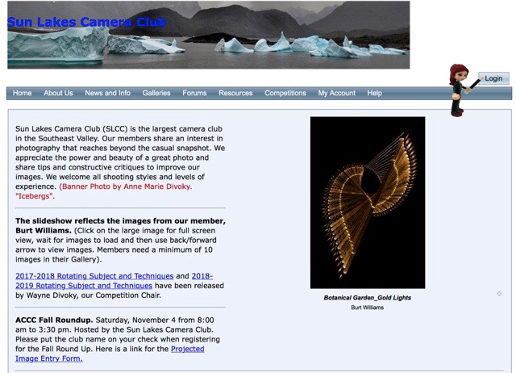

Step 3.
Login with your User Name and password. If you don’t remember your User Name, email me. If you don’t remember your password, click on the “Reset Password” button.
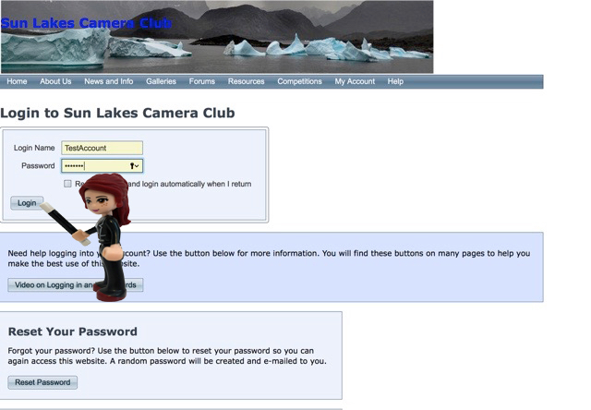

Step 4.
Select the Forums Page.
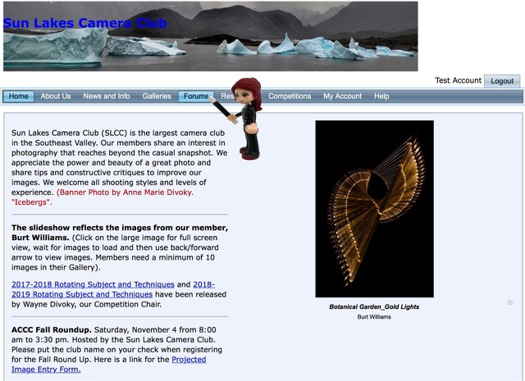

Step 5.
Select “Subscribe” to each forum that you wish, but make sure to select the “The President’s Corner” so you can receive all the emails and notifications from our President.

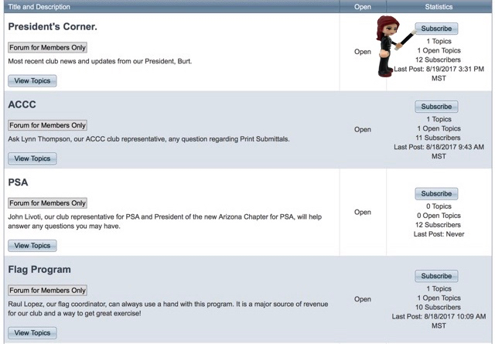

(Text by R. Little. Illustrations by N. Thoma)

